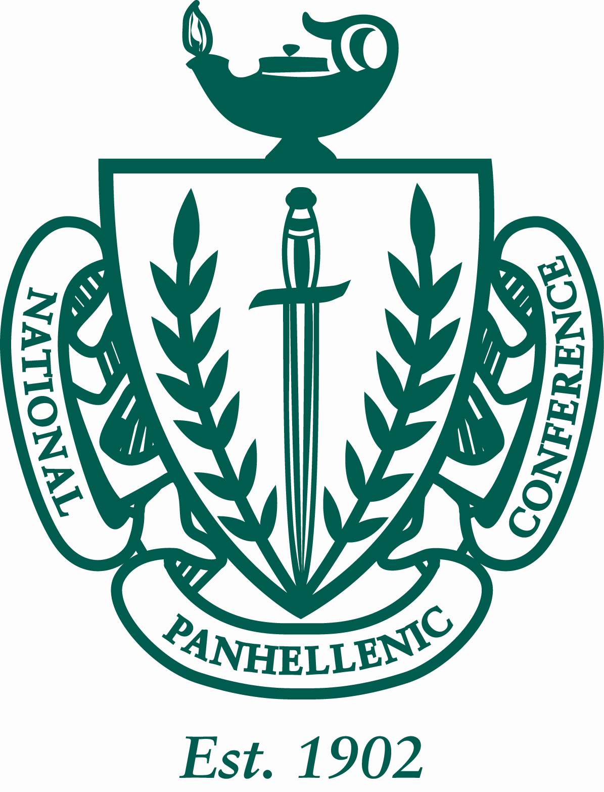

Minutes of the University of Louisiana at Lafayette Panhellenic Council
11/2/2015
The regular meeting was at 4:00pm in the U Pelican room on University of Louisiana at Lafayette’s campus. Roll was called.

ROLL CALL: Sigma Sigma Sigma (all present), Kappa Delta (all present), Delta Delta Delta (all present), Alpha Omicron Pi (all present), Phi Mu (all present) and Sigma Lambda Gamma (1st and 2nd absent) Alpha Delta Pi (all present) Gamma Rho Lambda (all present)

GUESTS:

PREVIOUS MINUTES: Previous minutes were approved as distributed.

TREASURER’S REPORT: The Treasurer reported as followed:

Beginning Balance (8/31/15) $18,698.29

Revenues: $0
Expenses: $0

Ending Balance (10/12/15): $17,643.47

The following bills were approved for payment: No Bills.

Committee Budgets:
Academic: 150
Social: 200
Philanthropy: 200

OFFICER REPORTS:

VP of Membership: no report

VP of Education: no report

VP of Judiciary: no report

Secretary:
Send in all announcements to my email, to make sure I have all the correct information. My email is graceeeg15@gmail.com .

REPORTS OF STANDING COMMITTEES

The Academic Committee report was presented by Grace Garza, Secretary: next drawing is the 16th A winner Skyla Stansbury and the B winner is Camran Brindley

The Philanthropy Committee report was presented by Morgan, – Panhellenic pride week March 7-11th
- Monday: wake up with Panhellenic and Badge day as well as facts that break stereotypes on social media
- Tuesday: circle for education, trying to get a speaker for that night
- Wednesday: wear your letters
- Thursday: coin challenge and together Thursday dealing social media promoting
- Friday: block party
- Saturday: day of service

The Social/Inner Greek Relation Committee was presented by, Ashleigh VP of Judiciary: Fall fest: going to have games like my big fat Easter but still have the gumbo! Potential date Nov 19th 4-6 at KD house start sharing the flyer! Yay! Order shirts now till Friday! Put pick up for the shipping section

REPORTS OF SPECIAL COMMITTEES

ANNOUNCEMENTS:

The following announcements were made:

Chapter Announcements:
- Tri Sigma- Nov. 8th chili cook-off $5 to eat any of the chili starts at 12 and teams have to be there for 9. We have give back night at pizza Artista tonight and Chili’s on Wednesday at the Pinhook lactation. Flyers will be attached
- Phi Mu- kickin for kid’s price went down to 100 per team and it is the last week to turn in teams. We have elections tonight Sunday we are visiting the local miracle network hospital.
- KD- elections tonight
- Tri delta:
- AOII- rose week next week
- ADPI- See attachment in the minutes for flyer
- SLG- 3rd annual November 17th cultural movie night
- GRL- beta class baked good and face painting at the union porch 10-2 Thursday

Dean Announcements:
- “Effective Officer Transition Starts Now” 4-5pm in the Forum room
- All organizations must submit new member rosters by next Monday!
- True Greek series- all IFC and NPC new members and 1-% of NPHC groups must go to 2 out of 3 speakers
  - November 4th 6pm
- Chili cook-off (tri sigma) November 8th
- Kickin for kids (phi mu) November 22nd
- Programming retreat mandatory for Greek presidents and council executive members January 11 &12, 2016
- Emerging leader’s summit: February 20,2016
- Panhellenic elections:
  - Nominations for committee due November 2nd
  - Nominations for running due November 9th
  - Present slate November 16th
  - Vote/accept slate November 23rd
  - Bisbano transition: November 30th
- Panhellenic pride week march 7-11
- Spring recruitment February 22-26
- Community services:
  - Alzheimer’s walk: November 14th

ADJOURNMENT:

The meeting adjourned at 4:31pm.

Grace Garza, Secretary

