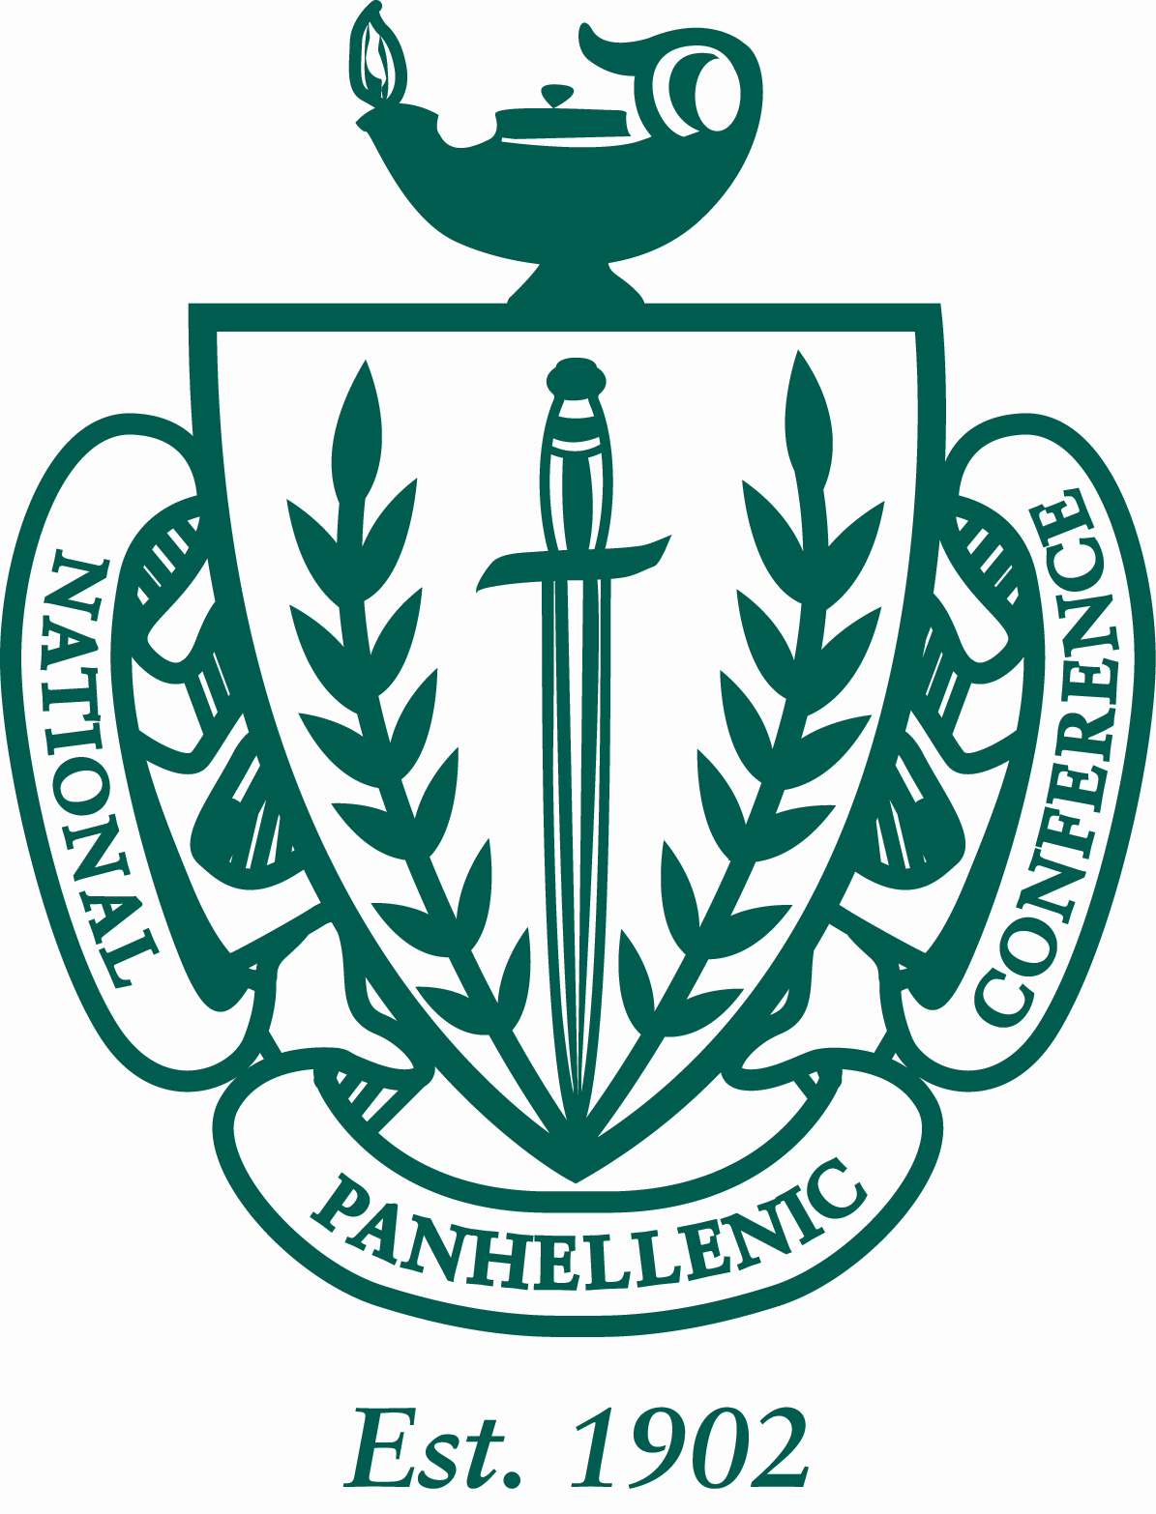

Minutes of the University of Louisiana at Lafayette Panhellenic Council
11/9/2015
The regular meeting was at 4:03pm in the U Helen B. Constantine Forum room on University of Louisiana at Lafayette’s campus. Roll was called.

ROLL CALL: Sigma Sigma Sigma (all present), Kappa Delta (all present), Delta Delta Delta (all present), Alpha Omicron Pi (all present), Phi Mu (all present) and Sigma Lambda Gamma (1st and 2nd absent) Alpha Delta Pi (2nd Delegate Absent) Gamma Rho Lambda (all present)

GUESTS: Rebecca Hebert: Soul Camp Lead Staff Fundraiser—Tie Dye with LEAD STAFF, Thursday November 19th, from 2:30-5:30pm in Girard Park. Soul Camp T-shirts: $10.00 each, and $5.00 per shirt to tie dye. Bring money to the Orientation Office (Buchanan Hall 3rd floor) by November 10th.

PREVIOUS MINUTES: Previous minutes were approved as distributed.

TREASURER’S REPORT: The Treasurer reported as followed:

Beginning Balance (8/31/15) $18,698.29

Revenues: $0
Expenses: $0

Ending Balance (11/12/15): $8,255.58

The following bills were approved for payment: No Bills.

Committee Budgets:
Academic: 150
Social: 200
Philanthropy: 200

OFFICER REPORTS:

President: Panhellenic Pride Week scheduled for March 7th-11th – TBA if date is staying; Spring Recruitment February 22nd-26th.

VP of Membership: Post Recruitment Meeting Tuesday, December 1st at 5pm in the Forum Room on the second floor in the Union. Past/New Presidents, Past/New VP Membership Recruitments, Advisors asked to attend.

VP of Education: no report

VP of Judiciary: no report

Secretary:
Send in all announcements to my email, to make sure I have all the correct information. My email is graceeeg15@gmail.com .

REPORTS OF STANDING COMMITTEES

The Academic Committee report was presented by Catherine Bailey, VP Judiciary: Start sending in A’s and B’s for the next Panhellenic Drawing. i. Smartie panty with A’s and B’s – A victoria Secret. Drawing every 2 weeks. Who ever has most collectively gets cookie cakes at last meeting.

The Philanthropy Committee report was presented by Morgan, – Panhellenic pride week March 7-11th -- Date TBA if staying this week.
- Monday: wake up with Panhellenic and Badge day as well as facts that break stereotypes on social media
- Tuesday: circle for education, trying to get a speaker for that night
- Wednesday: wear your letters
- Thursday: coin challenge and together Thursday dealing social media promoting
- Friday: block party
- Saturday: day of service

The Social/Inner Greek Relation Committee was presented by, Ashleigh VP of Judiciary: Fall fest: going to have games like my big fat Easter but still have the gumbo. Date: Nov 19th 4:30-6:30 at KD house start sharing the flyer! Yay! Alana will contact you when the shirts are in. ***NOTE time has changed***

REPORTS OF SPECIAL COMMITTEES

ANNOUNCEMENTS:

The following announcements were made:

Chapter Announcements:
- Tri Sigma- Thank you all for the support at our Chili Cookoff!
- Phi Mu- kickin for kid’s price went down to 150 per team and it is the last week to turn in teams. Mixer with Sig Gamm Rho in Constantine B- 6:22pm Rhovember forum just conversation and mingling with women. Come!!!
- Tri Delta- semi Saturday
- KD- no announcements
- AOII- Week Nov 9-13/14—Mon. Pie a Pi, Tues. Arthritis booth TBD, Wed. Sisters for Soldiers drop box donations deadline next Wednesday, Friday. Rose sale 9-11am, Wednesday Slice of Pi at Mellow all day homie get to pizza. Yoga Night Thursday- Monetary Donation 6-7pm at the AOII house
- ADPI- Mini Masters Tournament Tues Nov 24th at the intramural fields, 7-9pm. Cost is $5 and tickets can be purchased from any ADPi member!
- SLG- 3rd annual November 17th cultural movie night
- GRL- no announcements

Dean Announcements:
- All organizations must submit new member rosters by TODAY!
- Org Sync Training every Wednesday @ 4pm in the Forum Room
- Panhellenic Fall Fest: November 19th 4:30-6:30 @ the KD House
- Kickin for kids Kickball Fall Fest(phi mu) November 22nd
- Rose Week ( Alpha Omicron Pi) November 9-14:
  - Rose sale: Novemeber 13th
  - Give back night at Mellow Mushroom: November 12
  - BBQ- November 14th
- Programming retreat mandatory for Greek presidents and council executive members January 11 &12, 2016
- Emerging leader’s summit: February 20,2016
- Panhellenic elections:
  - Nominations for committee due November 2nd
  - Nominations for running due November 9th
  - Present slate November 16th
  - Vote/accept slate November 23rd
  - Bisbano transition: November 30th
  - **Members nominated must be present at November 23rd Meeting**
- Panhellenic pride week march 7-11
- Spring recruitment February 22-26
- Community services:
  - Alzheimer’s walk: November 14th

ADJOURNMENT:

The meeting adjourned at 4:50pm.

Grace Garza, Secretary

