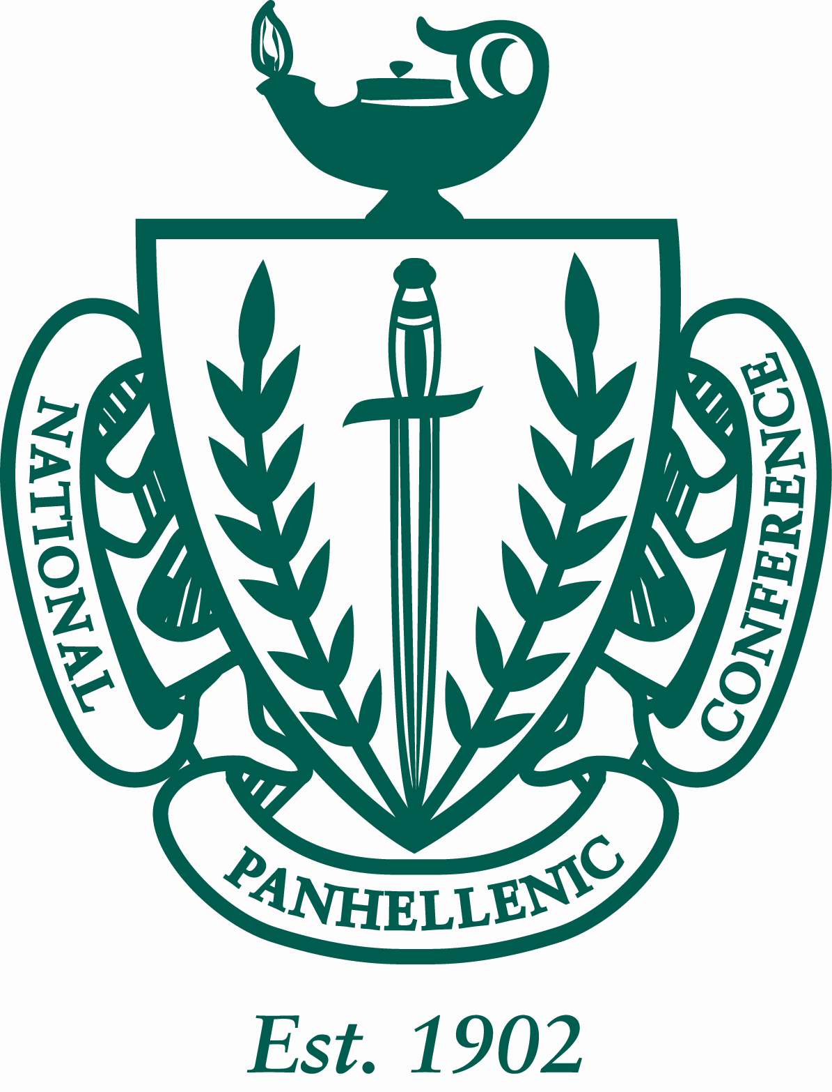

Minutes of the University of Louisiana at Lafayette Panhellenic Council
10/19/2015
The regular meeting was at 4:00pm in the U Pelican room on University of Louisiana at Lafayette’s campus. Roll was called.

ROLL CALL: Sigma Sigma Sigma (all present), Kappa Delta (all present), Delta Delta Delta (all present), Alpha Omicron Pi (all present), Phi Mu (all present) and Sigma Lambda Gamma (all absent) Alpha Delta Pi (all present)

GUESTS:

PREVIOUS MINUTES: Previous minutes were approved as distributed.

TREASURER’S REPORT: The Treasurer reported as followed:

Beginning Balance (8/31/15) $18,698.29

Revenues: $0
Expenses: $0

Ending Balance (10/12/15): $17,643.47

The following bills were approved for payment: No Bills.

Committee Budgets:
Academic: 150
Social: 200
Philanthropy: 200

OFFICER REPORTS:

VP of Membership: no report

VP of Education: no report

VP of Judiciary: no report

Secretary:
Send in all announcements to my email, to make sure I have all the correct information. My email is graceeeg15@gmail.com .

REPORTS OF STANDING COMMITTEES

The Academic Committee report was presented by Grace Garza, Secretary: 26th is the next drawing turn in A’s and B’s the night before

The Philanthropy Committee report was presented by Morgan, – Panhellenic pride week March 7-11th
- Monday: wake up with Panhellenic and Badge day as well as facts that break stereotypes on social media
- Tuesday: circle for education, trying to get a speaker for that night
- Wednesday: wear your letters
- Thursday: coin challenge and together Thursday dealing social media promoting
- Friday: block party
- Saturday: day of service

The Social/Inner Greek Relation Committee was presented by, Ashleigh VP of Judiciary: Fall fest: going to have games like my big fat Easter but still have the gumbo! Potential date Nov 19th 4-6 at KD house

REPORTS OF SPECIAL COMMITTEES

Old business: Motion made by Amy Boraks and seconded by Katie Wappel to vote on to accept Gamma Rho Lambda into panhellenic as an associate chapter. Voting in the affirmative: Tri Sigma, Tri Delta, Kappa Delta, Alpha Omicron Pi, and Alpha Delta Pi. Voting in the negative: none.

ANNOUNCEMENTS:

The following announcements were made:

Chapter Announcements:
- Tri Sigma- Nov. 8th chili cook-off we had bog/lil yesterday
- Phi Mu- kickin for kids price went down to 100 per team we had big/lil this weekend and competing in shimmy like a nupe 7-11
- KD-
- Tri delta: we are performing for shimmy like a nupe and initiation this Sunday
- AOII- initiation this Sunday
- ADPI-
- SLG-

Dean Announcements:
- True Greek series- all IFC and NPC new members and 1-% of NPHC groups must go to 2 out of 3 speakers
  - October 22nd 7pm
  - November 4th 6pm
- New UL Greek Life instagram page @GeauxGreekUL
- Mini Gamma week (sigma lambda gamma) is October 14th-16th
- Chili cook-off (tri sigma) November 8th
- Kickin for kids (phi mu) November 22nd
- Homecoming 2015- “UL through the years” October 26-31
- Programming retreat mandatory for Greek presidents and council executive members January 11 &12, 2016
- Emerging leader’s summit: February 20,2016
- Panhellenic elections:
  - Nominations for committee due November 2nd
  - Nominations for running due November 9th
  - Present slate November 16th
  - Vote/accept slate November 23rd
  - Bisbano transition: November 30th
- Panhellenic pride week march 7-11
- Spring recruitment February 22-26
- Risk Management- college sexual assault presentation will be held October 12th at 6pm on the student union in the bayou bijou. Speaker will be Val Senegal, and attendance will count towards excellence packets
- Community services:
  - Community Service fair October 21 11-1pm
  - Alzheimer’s walk: November 14th

ADJOURNMENT:

The meeting adjourned at 4:39pm.

Grace Garza, Secretary

